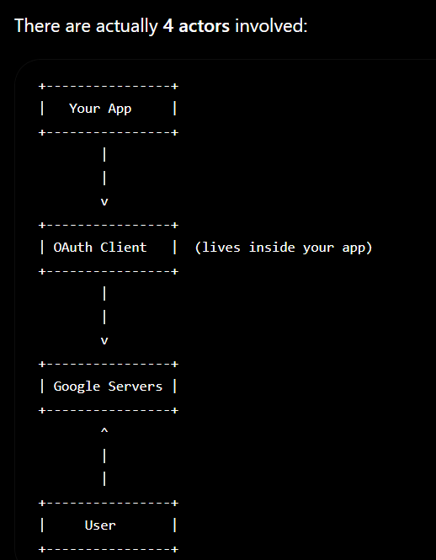
1. Your App
This is your backend.
Example:
server.js
calendar.js
routes.js
It wants to do something like:
"Create an event in the user's calendar."
But it cannot directly access Google Calendar.

2. OAuth Client
This is not a separate server.
This is where many beginners get confused.
When you write
const authClient = new google.auth.OAuth2(...)
you're just creating a JavaScript object inside your app.
Think of it as a Google translator.
Instead of your app talking directly to Google,
Your App
↓
OAuth Client
↓
Google
The OAuth client knows:
- your client_id
- your client_secret
- redirect URI
- access token
- refresh token
and handles all the OAuth protocol for you.
So it lives inside your app, not on Google's servers.

3. Google Servers
These are Google's authentication servers.
They do things like:
- Show the login page
- Verify username/password
- Ask the user
Allow this app
to access your calendar?
- Generate access tokens
- Generate refresh tokens
- 4. User
- The user is the owner of the calendar.
- Google will never let your app access someone's calendar unless the user says:
- YES
I ALLOW IT

User
|
|
v
+----------------------+
| Your App |
+----------------------+
|
|
Creates OAuth Client
|
v
+----------------------+
| OAuth Client Object |
+----------------------+
|
|
Sends request
|
v
+----------------------+
| Google Servers |
+----------------------+
|
|
Shows Login Page
|
v
User Logs In
|
Clicks Allow
|
v
Google creates Tokens
|
|
Returns Tokens
|
v
OAuth Client stores them
|
|
Your App can now call
Google Calendar API

